Depth First Search Problem in Python:
Aim:
To implement the Depth First Search (DFS) algorithm in Python for graph traversal in Artificial Intelligence.
Objective:
- Implement the Depth First Search (DFS) algorithm in Python.
- Traverse a graph by exploring one branch completely before backtracking.
- Visit all reachable nodes using a stack (recursion).
- Understand the application of DFS as an uninformed search algorithm in Artificial Intelligence.
Algorithm:
- Start the program.
- Input the number of vertices in the graph.
- Create the graph using an adjacency list by entering each vertex and its adjacent vertices.
- Input the starting vertex from which the DFS traversal will begin.
- Initialize an empty set called visited to keep track of the visited vertices.
- Call the DFS function with the graph, starting vertex, and visited set.
- In the DFS function:
- Check if the current vertex has already been visited.
- If not visited:
  - Mark the current vertex as visited.
  - Display the current vertex.
  - Traverse each adjacent vertex of the current vertex.
  - If an adjacent vertex has not been visited, recursively call the DFS function for that vertex.
- Repeat the recursive process until all reachable vertices have been visited.
- Terminate the program after the traversal is completed.

Flow Chart:
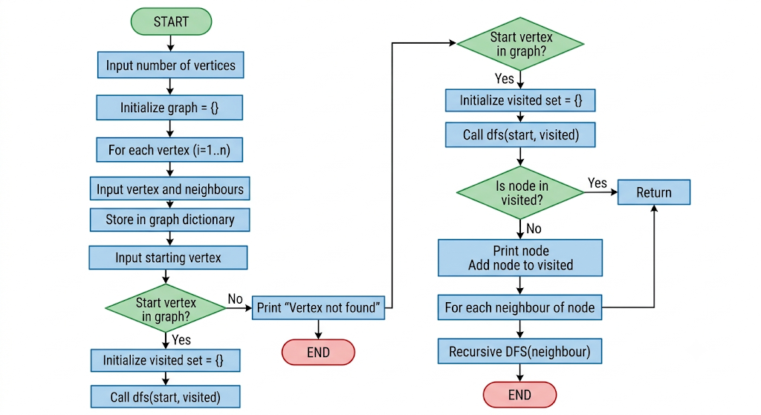
Python Code:
# Depth First Search (DFS) using Recursion
def dfs(graph, node, visited):
if node not in visited:
print(node, end=" ")
visited.add(node)
for neighbour in graph[node]:
dfs(graph, neighbour, visited)
# Main Program
graph = {}
n = int(input("Enter the number of vertices: "))
for i in range(n):
vertex = input(f"Enter vertex {i+1}: ")
neighbours = input(f"Enter adjacent vertices of {vertex} (space-separated): ").split()
graph[vertex] = neighbours
start = input("\nEnter the starting vertex: ")
if start in graph:
print("\nDepth First Search Traversal:")
visited = set()
dfs(graph, start, visited)
else:
print("Starting vertex not found in the graph.")
Sample Output:
Depth First Search Traversal:
A B D E C
Result:
